-Introduction

1. Give an overall intro of your project.  Why you did it? What are the factors of interest
   1. Our project was sparked by an original assignment by Brother Cromar. We threw paper airplanes and measured the distances that they flew. After thinking about this activity, we thought about furthering the assignment and changing our factors of interest. We wanted to see how the fold of each airplane would affect the distance that it would fly. Then doing research to figure out a little bit more about planes and flying, we were able to identify a distinguishable design for all plane, the wing tips. We therefore decided to include design and winglets as our two factors of interest. By narrowing in on these two factors, we were able to eliminate a lot of other variables that could have been a great nuisance.
2. What are the null and alternative hypotheses
   1. H0: Mean flight distance is the same for all designs.
   2. Ha: Mean flight distance is different for at least one of our designs.
   3. H0: Mean flight distance is the same for all winglets.
   4. Ha: Mean flight distance is different for at least one of our winglets.
   5. H0: There is no interaction between plane design and winglets.
   6. Ha: There is at least some interaction between plane design and winglets.

-Data Collection

1. Randomization
   1. Through our experiment, we use randomization in all areas of the experiment where possible. We randomized the throwing order by using a die to determine which plane was thrown with each observation. We also randomized the planes that were given the winglets.
2. Controlling
   1. We controlled for many factors to be able to have a valid experiment.
      1. We only had one thrower to control skill level
      2. We only had one plane maker to control for fold style
      3. We only had one type of paper to control for any differences in material
3. Treatments
   1. Plane design
      1. Delta
      2. Weighted
      3. Snub
   2. Winglets
      1. Up
      2. Down
      3. Flat
4. Response
   1. Our response was the absolute distance flown by an airplane. This means that we measured straight from the thrower to the farthest point of the airplane from the thrower. We measured in inches.
5. After Designing it, how did it go?
   1. After designing the experiment we ran into a few issues. First, we tried throwing in a hallway assuming all would go straight. That did not happen. Second, we tried to include thrower as a variable of interest, but quickly determined that this would not be the best way to measure. After we realized these things, we adjusted the experiment and then moved forward with our questions. Our experimental design worked very well with our data and allowed us to continue forward and make the observations that were desired.
6. What was your overall sample size?
   1. We ran power to see how many sample sizes were needed to be able to have 80% power and detect a difference of 33 inches. We determined that we needed to have 10 samples per group. We determined this given an estimated variance, which did not turn out the way that we expected.

-Descriptive Statistics

1. Numerical Descriptive Statistics
   1. 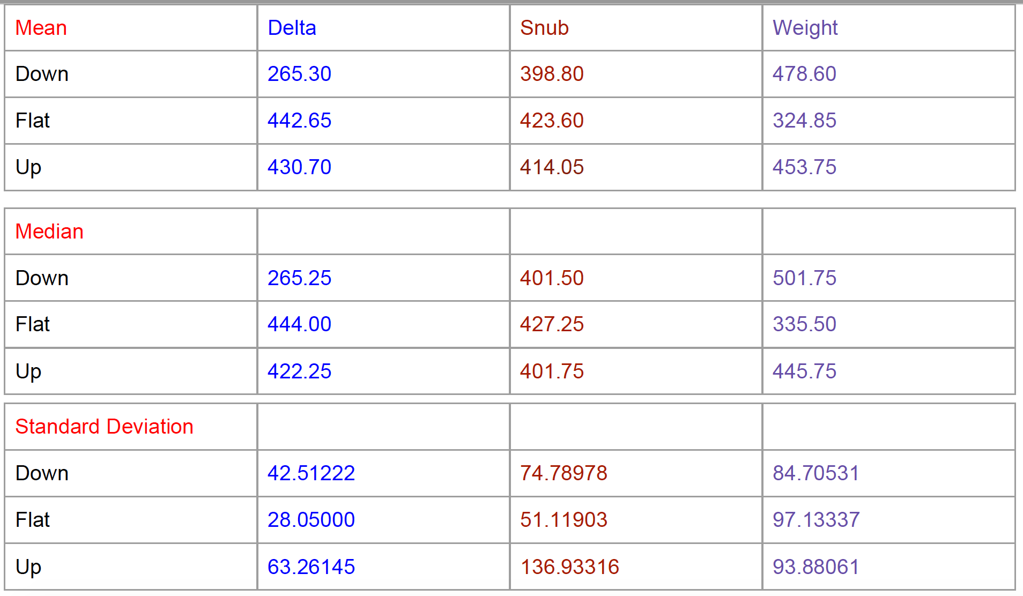
   2. 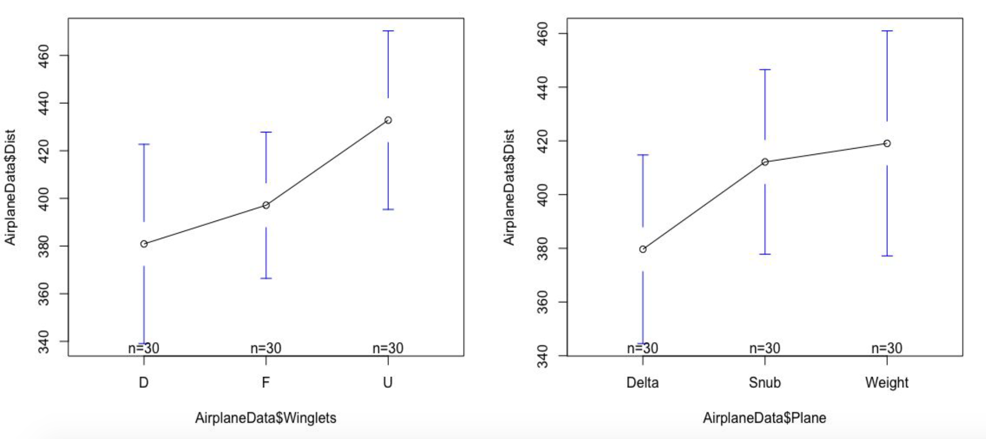
   3. 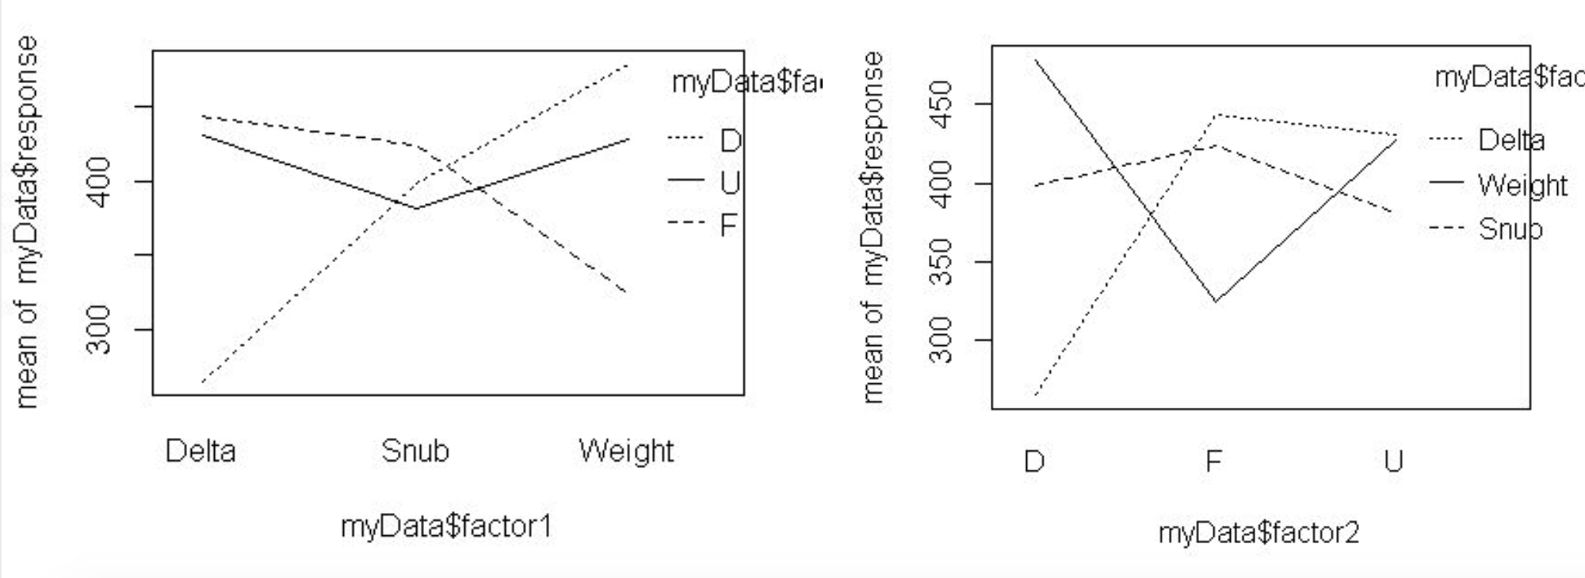
2. Graphical Descriptive Statistics
   1. 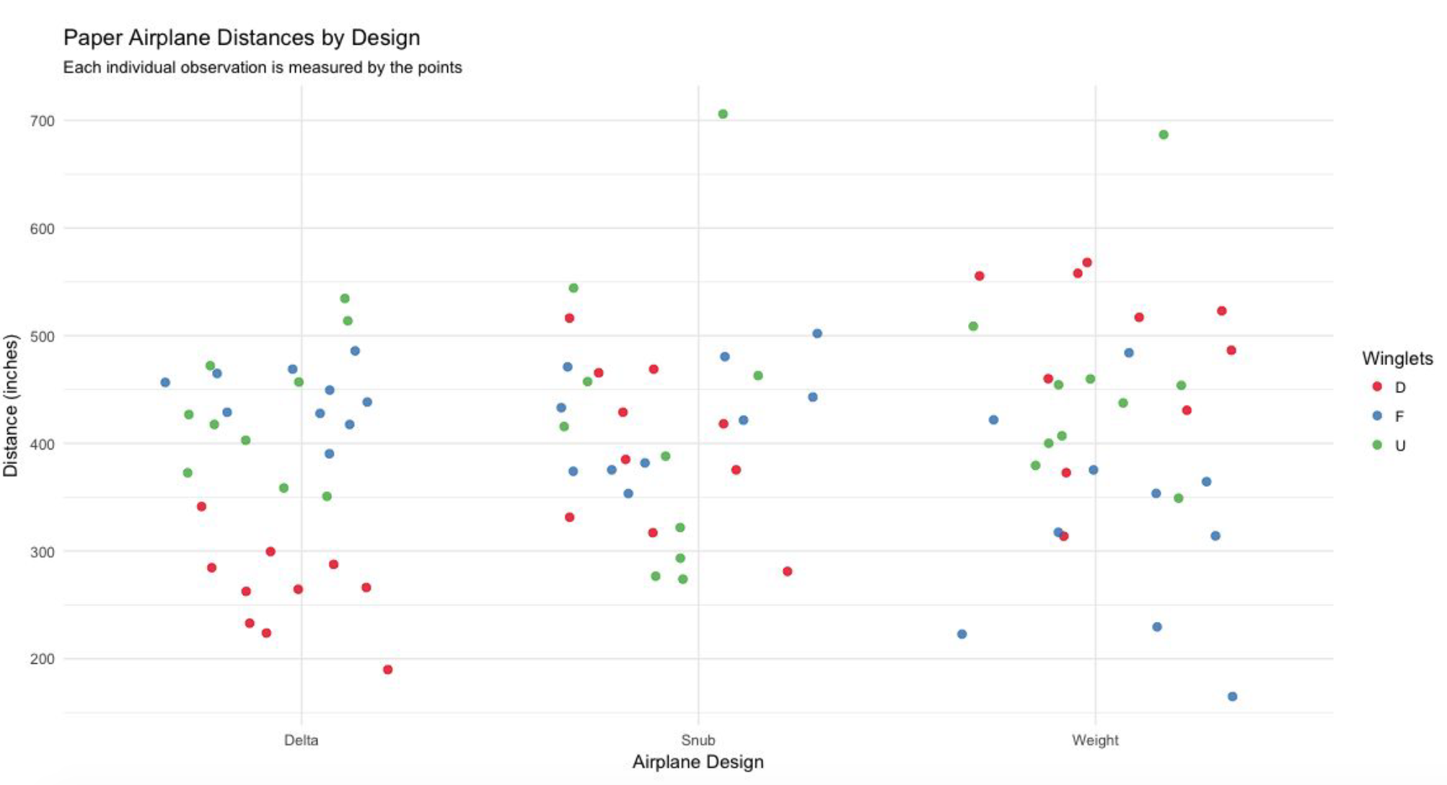
   2. 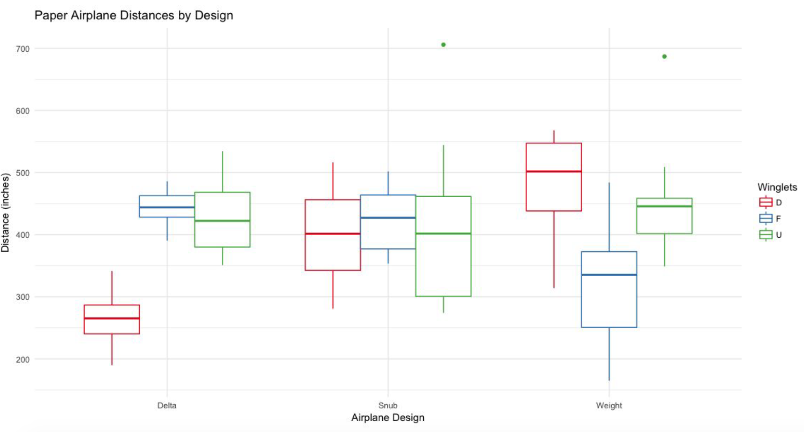
3. “Tell a story” based on what you see in your descriptive statistics
   1. In the descriptive statistics we have been excited by the way that everything looks. We have been able to see in the numerical statistics that there is clearly differences in the means, medians and SDs. Through the graphical summaries we have been able to see much more clearly which groups are different from the others and how they come into play. We see that each plane has its own interaction with the winglets. Two of the planes change greatly by introducing winglets, while one design does not change much at all. We are also able to see general trends in the data while looking at the winglets. The downward winglets have an upward trend moving left to right across the designs, while the flat has the revers affect. Interestingly enough, the up winglets seemed to control the planes and keep them around the same median point across all three designs.

-Inferential Statistics

1. Checking Requirements
   1. 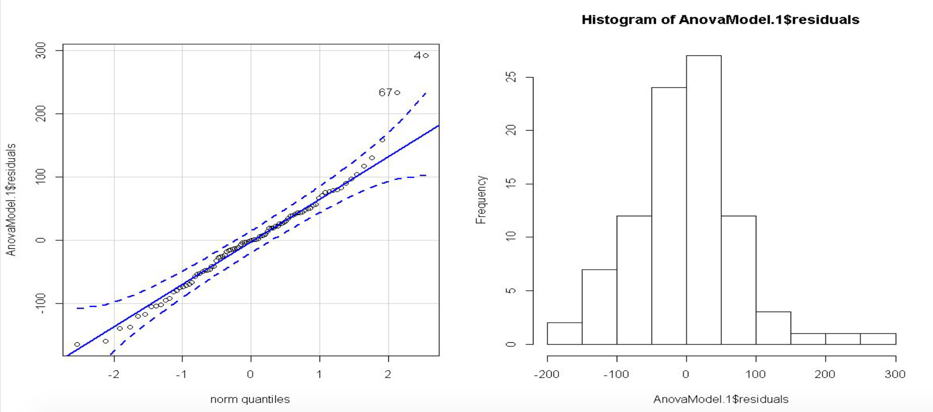
2. ANOVA table, df,SS, MS, F, p-value
   1. 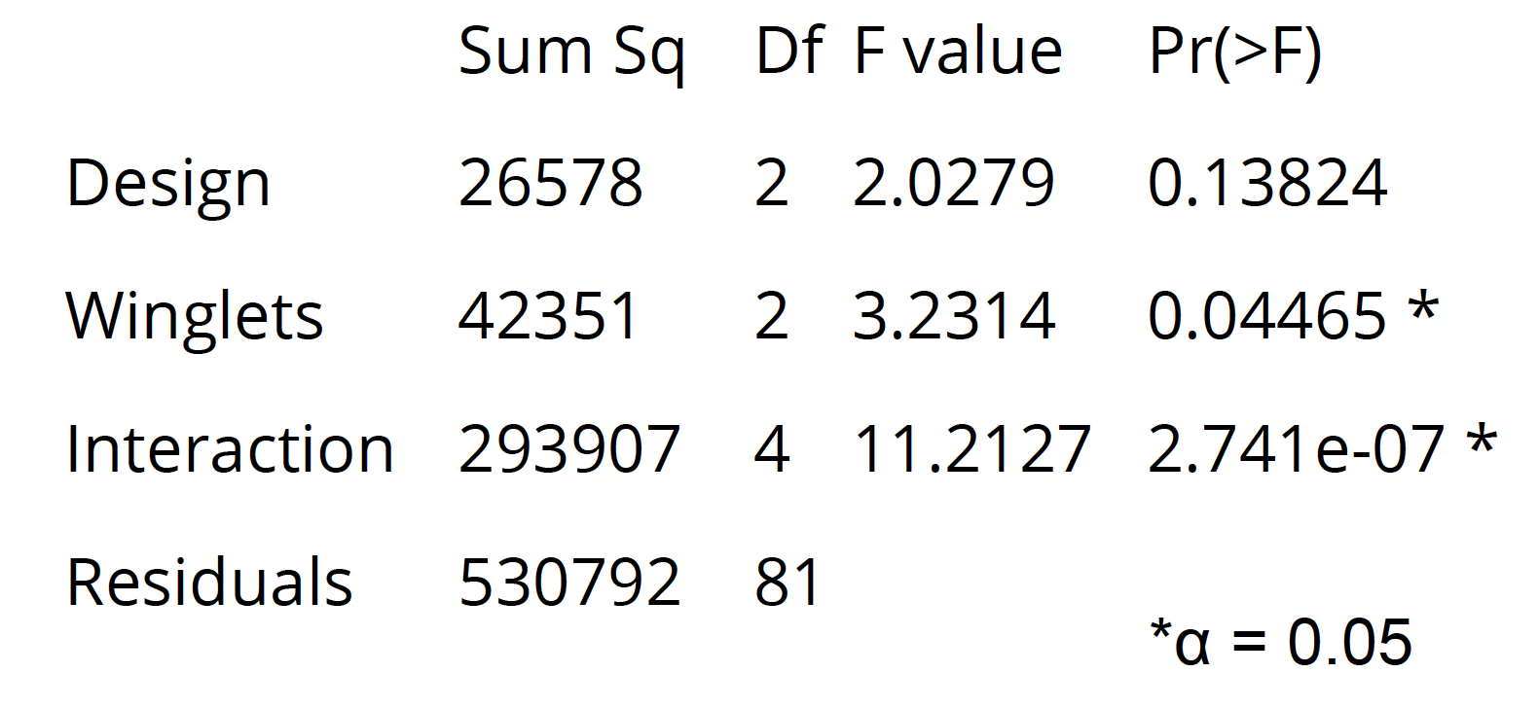
3. Decision rule (level of significance)
   1. 0.05 alpha
4. Any mean differences or mean treatment combinations that stand out?
   1. Through the anova table, we are able to clearly identify that the winglets and interaction yield significant results. This means that there is a difference between at least one of the group means for winglets and that an interaction between design and winglets exists.

-Conclusion

1. General Conclusion of your results based on decision rule
   1. We fail to reject the null hypothesis for design
   2. We reject the null hypothesis for the winglets
   3. We reject the null hypothesis that there is no interaction
2. Why do you think you got the results you did?
   1. We believe that our results were obtained through sound experimental design. We acknowledge our inexperience, but see that we did a good job with our desing. We worked hard to control all variables and achieve our desired outcomes of finding unbiased observations. We found ourselves at moments trying to correct concerns, but held back the reigns in order for science to move forward.
3. What would you have done differently?
   1. We would have liked to have had more designs, a larger sample size and a way to measure the true distance traveled. Our limited measurement tools did not allow for us to measure the distance traveled by a plane that did circles. This would have been a great tool. We would have also like to have had a new airplane for each toss instead of using only one for each combination of design and winglet.
4. Any follow up studies that you would have done?
   1. We would like to see studies that include a much larger sample size of the planes. Also we would like to see some more advanced measurement techniques to be able to account for distance traveled overall, not only from the thrower.

-Three references of Peer-reviewed articles in APA formatting

Maughmer, M. D., & Swan, T. S. (2002) Design and testing of a winglet airfoil for low-speed aircraft. Journal of Aircraft, 39(4), 654-661. doi:10.2514/2.2978

Parenteau, M., Laurendeau, É., & Carrier, G. (2018). Combined high-speed and high-lift wing aerodynamic optimization using a coupled VLM-2.5D RANS approach. Aerospace Science and Technology, 76, 484-496. doi:10.1016/j.ast.2018.02.023

Sobieszczanski-Sobieski, J., & Haftka, R. T. (1997). Multidisciplinary aerospace design optimization: Survey of recent developments. Structural optimization, 14(1), 1-23